**[Telephony and Media Audio Profile](https://www.bluetooth.com/specifications/tmap-1-0/)**

This profile establishes configuration settings of underlying audio-related specifications to allow manufacturers to deliver interoperable conversational, streaming, and broadcast audio user experiences in a wide variety of telephony and media products.

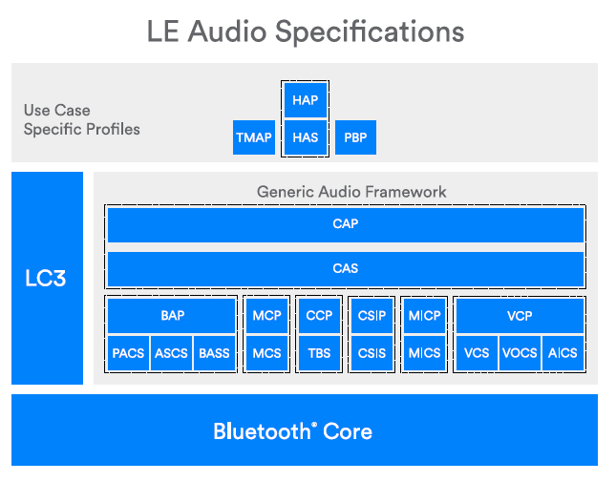

## Roles

All TMAP roles must support the 2M PHY, which will almost certainly be necessary to find enough airtime for these configurations

For telephony

The **Call Gateway (CG)** role is defined for telephony or VoIP(voice-over Internet protocol) applications. The CG device has the connection to the call network infrastructure.

The **Call Terminal (CT)** role is defined for headset type devices in telephony or VoIP applications.

Devices supporting the CG and CT Roles must support the higher codec settings of 32 kHz sampling at both 7.5ms and 10ms frame rates (32_1 and 32_2 from BAP), with the Low Latency settings.

A CG must support the CCP(Call Control Profile ) Server role, but does not mandate any further features above those mandated in CCP.

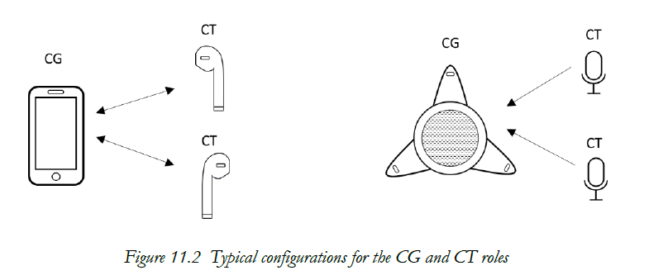

For Media Player:

The **Unicast Media Sender (UMS)** role is defined for devices that send media audio content in one or more Unicast Audio Streams. must support the 48_2 codec setting and at least one of the 48_4 or 48-6 settings

The **Unicast Media Receiver (UMR)** role is defined for devices that receive media audio content from a source device in one or more Unicast Audio Streams. requiring a Unicast Media Receiver to support all six of the 48kHz sampling codec configurations, form 48_1 to 48_6.

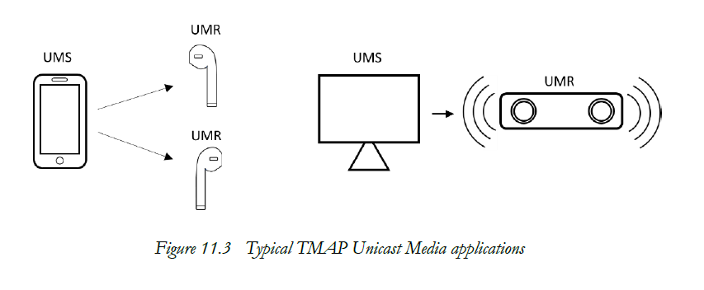

For broadcast

The **Broadcast Media Sender (BMS)** role is defined for devices that send media audio content to any number of receiving devices. Typical devices implementing the BMS role include smartphones, media players, TVs, laptops, tablets, and PCs.

The Broadcast Media Receiver (BMR) role is defined for devices that receive media audio content from a source device in a broadcast Audio Stream. requiring support for all of the Low Latency and High Reliability 48 kHz QoS modes defined in table 6.1 of BAP (48_1_1 to 48_6_1 and 48_1_2 to 48_6_2) for a Broadcast Media Receiver

TMAP requires that Broadcast Media Receivers support a Presentation Delay value of 20ms within their range of Presentation Delays for both Low Latency and High Reliability

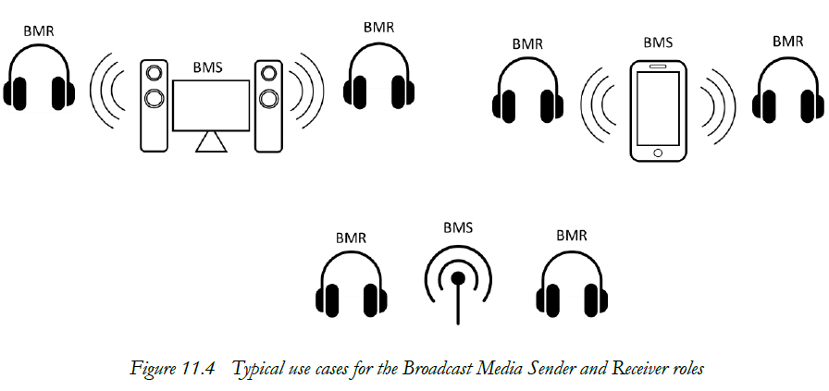

TMAP adopts the device discovery and connection establishment recommendations as specified by CAP and BAP

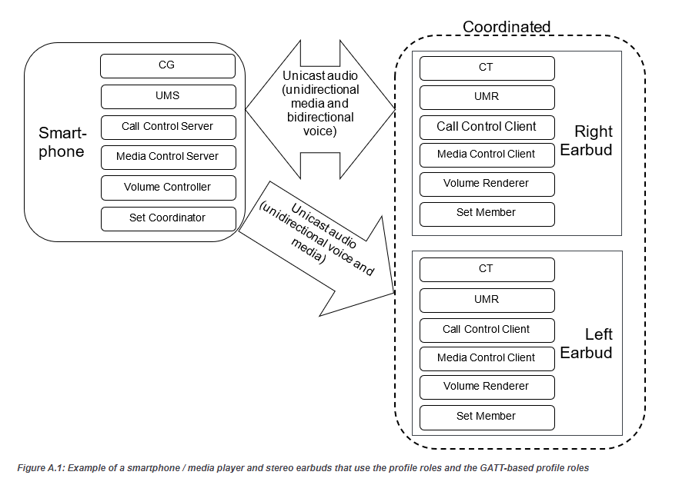

## Profile dependencies

### 

The following sets of profiles and services fall under each of the boxes shown in Figure 2.1:

• Content Control:

o Media Control Profile (MCP) : Play or pause

o Media Control Service (MCS) and Generic Media Control Service (GMCS) [13]

o Call Control Profile (CCP) [6]

o Telephone Bearer Service (TBS) and Generic Telephone Bearer Service (GTBS) [14]

• Capture and Rendering Control:

o Volume Control Profile (VCP) [5]

o Volume Control Service (VCS) [15]

• Audio Stream Transitions:

o Basic Audio Profile (BAP) [4]

o Broadcast Audio Scan Service (BASS) [16]

o BASS is listed here for completeness. TMAP specifies no additional requirements for the BASS Server (Scan Delegator) or the BASS Client (BAP Broadcast Assistant).

o Published Audio Capabilities Service (PACS) [2]

o Audio Stream Control Service (ASCS) [1]

o Coordinated Set Identification Profile (CSIP) [9]

o Coordinated Set Identification Service (CSIS) [17]

**Test**

The test objectives are to verify the functionality of the Telephony and Media Audio Profile Specification within a Bluetooth Host and enable interoperability between Bluetooth Hosts on different devices.

1. conformance testing require device set parameters and check if set correctly
2. simulates telephony
3. requirements to ensure synchronization between multiple audio channels transmitted across multiple Audio Streams

test every device with every other qualified device, ensuring that phase delay is kept to an acceptable minimum between any two platforms in an absolute delay

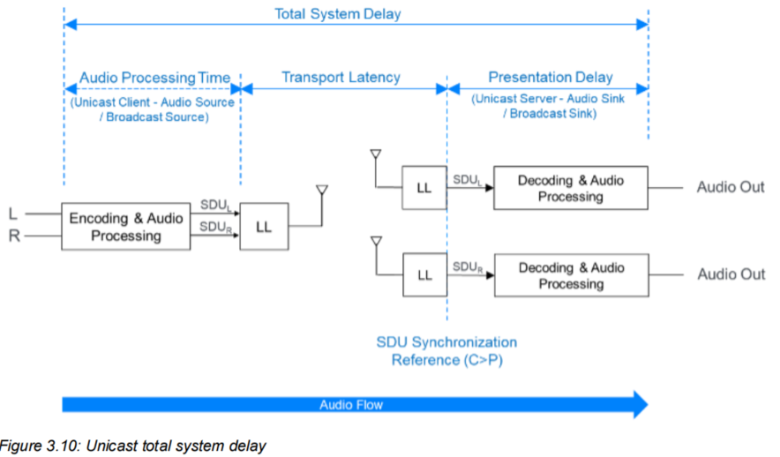

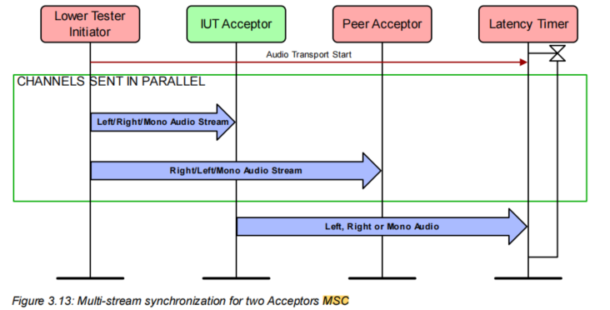

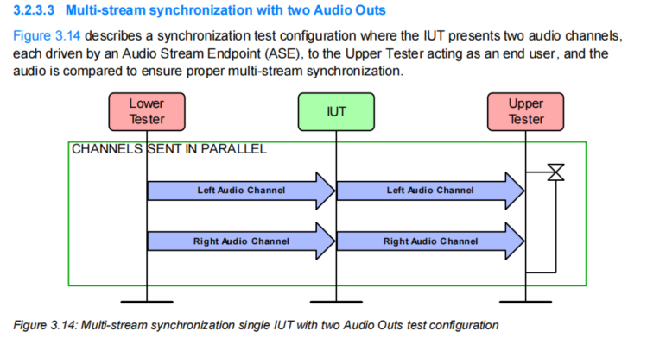

Multi-stream synchronization test methodologies :

Audio reference signal : 500~5kHZ

Audio reference signal :amplifier output.

Test methods for measuring latency between left and right channels

:

Measured skew or timing offset

Instantaneous phase measurement

Cross-correlation

1. BI/BV test

* TMAP verification by role and configuration
* Audio Stream Transitions control
* Multichannel synchronization
* Telephony and Media Audio Client and Server
* Device discovery

